NIP Project — Submission
Pega Platform project · Movie Ticket Booking Management Application
This document reflects the confirmed project details supplied for the Movie Ticket Booking System project. Values are taken from the screenshots where visible; a small number of items (marked "Needs screenshot verification") could not be independently confirmed from a Pega screen and are noted as such rather than invented.

Section 1 — Your Details
Full Name | Subiksha S
Email ID (registered on NIP) | subiksha780@gmail.com
Phone Number | 7867819945
College Name | VSB Engineering College, Karur
Course (e.g. IT, CS) | BE Computer and Communication Engineering
State | Tamil Nadu
Project Chosen | Movie Ticket Booking
Pega Application Name | Movie Ticket Booking System
Case Type Name (exact) | Movie Ticket Request
Pega Instance URL | https://b7t2prxq.pegaacademy.net/prweb/app/fraud-investigation/
Operator Name | author@uplus (designated Author operator specified by the exercise instructions)

Section 2B — Movie Ticket Booking Management Application
Screenshots below are the strongest available evidence for each user story and have not been edited or altered.

US-1 — Submit Movie Ticket Request
What is expected:
Case created, customer submits Movie Name, Show Date, Show Time, Number of Tickets. Validation applied.
Screenshot evidence:
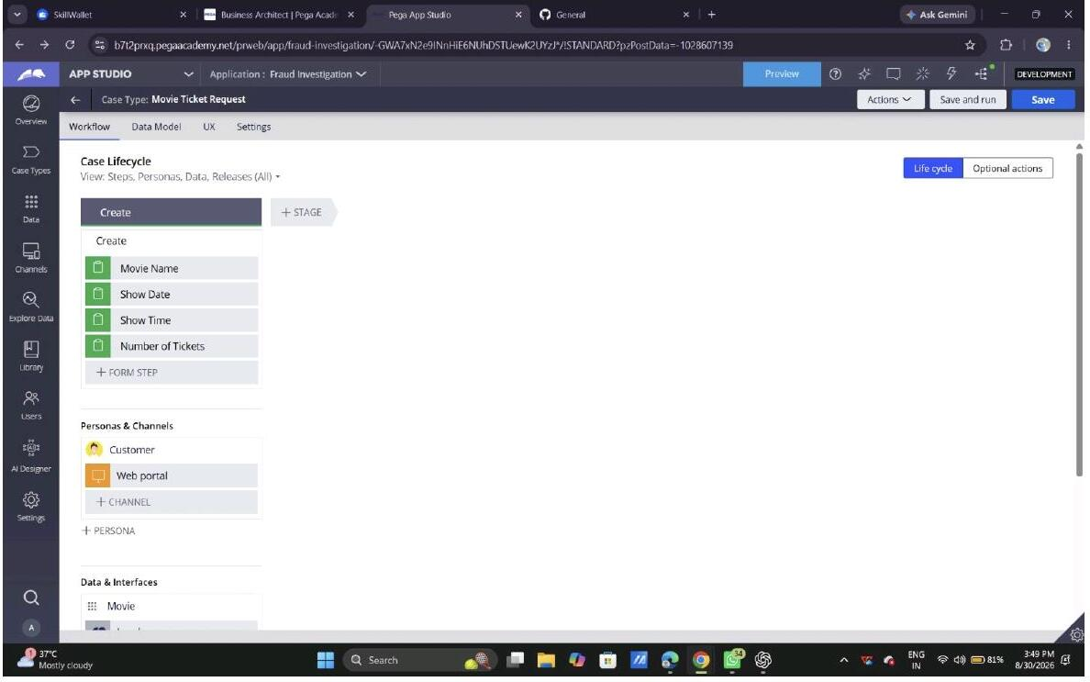
What I built for this:
Configured the Create stage of the Movie Ticket Request case type with four form fields — Movie Name, Show Date, Show Time, and Number of Tickets — captured from the Customer persona through the Web portal channel. (No running-case screenshot with these fields filled in was in the provided evidence, so this is shown from the case-type configuration view; please add a filled-in runtime screenshot if one is required.)

US-2 — Check Show Availability
What is expected:
Availability stage. Seat Availability Status and Available Seats Count captured. Booking proceeds only if available.
Screenshot evidence:
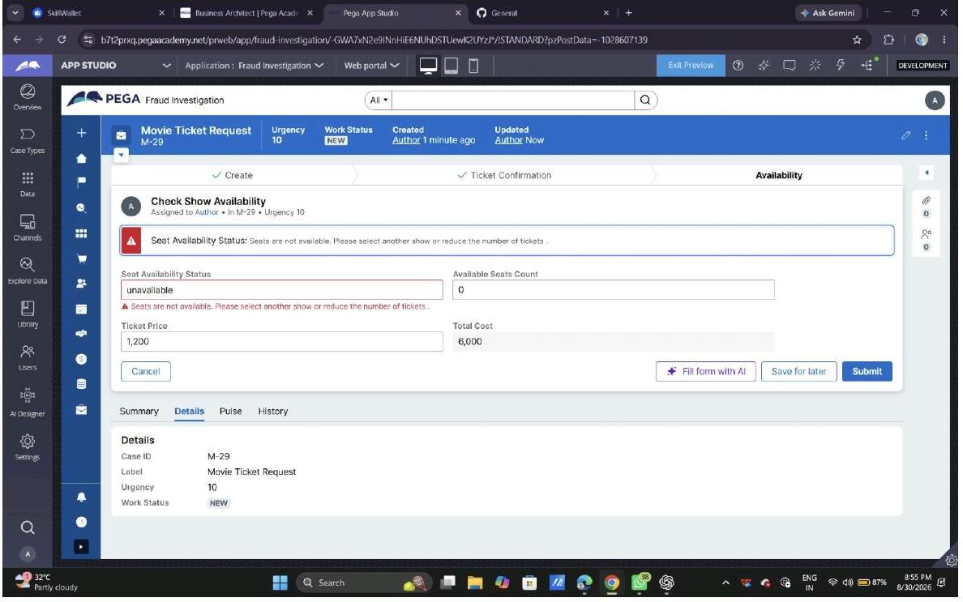
What I built for this:
Built the Availability stage with a Check Show Availability step capturing Seat Availability Status and Available Seats Count. When status is set to unavailable, the case shows a validation message ('Seats are not available. Please select another show or reduce the number of tickets.') and blocks the customer from proceeding.

US-3 — Calculate Booking Cost
What is expected:
Total Cost calculated automatically from Ticket Price and Number of Tickets using a business rule.
Screenshot evidence:
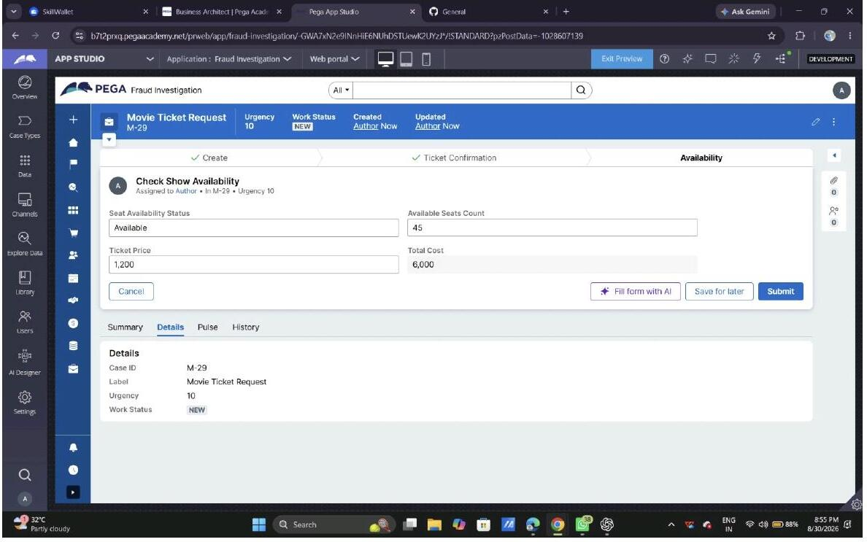
What I built for this:
Added a Ticket Price field alongside the availability details; Total Cost is then calculated automatically as Number of Tickets × Ticket Price and shown as a read-only field (e.g. Ticket Price 1,200 produced Total Cost 6,000).

US-4 — Confirm Booking Request
What is expected:
Approval stage assigned to Customer. Booking Status captured. Flow branches on confirm/cancel.
Screenshot evidence:
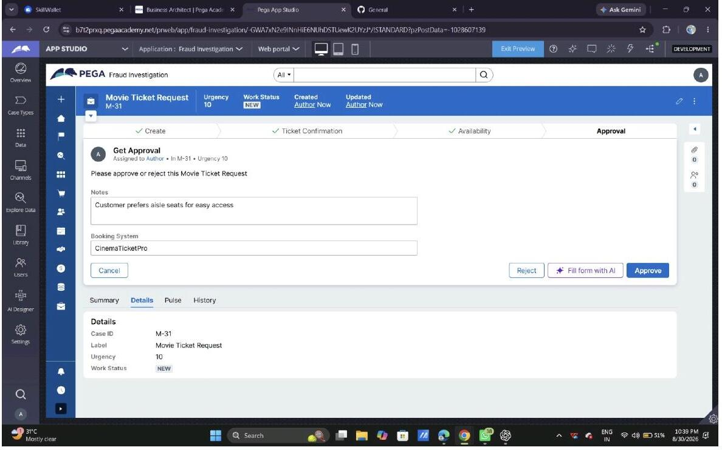
What I built for this:
Added a Get Approval step in the Approval stage with Notes and Booking System fields, and Approve/Reject actions that branch the case (a rejected case resolves as RESOLVED-REJECTED).

US-5 — Maintain Movie and Show Data
What is expected:
Reusable Movie and Show data objects created with Movie Name, Genre, Show Date, Show Time, Seat Capacity — linked to the case.
Screenshot evidence:
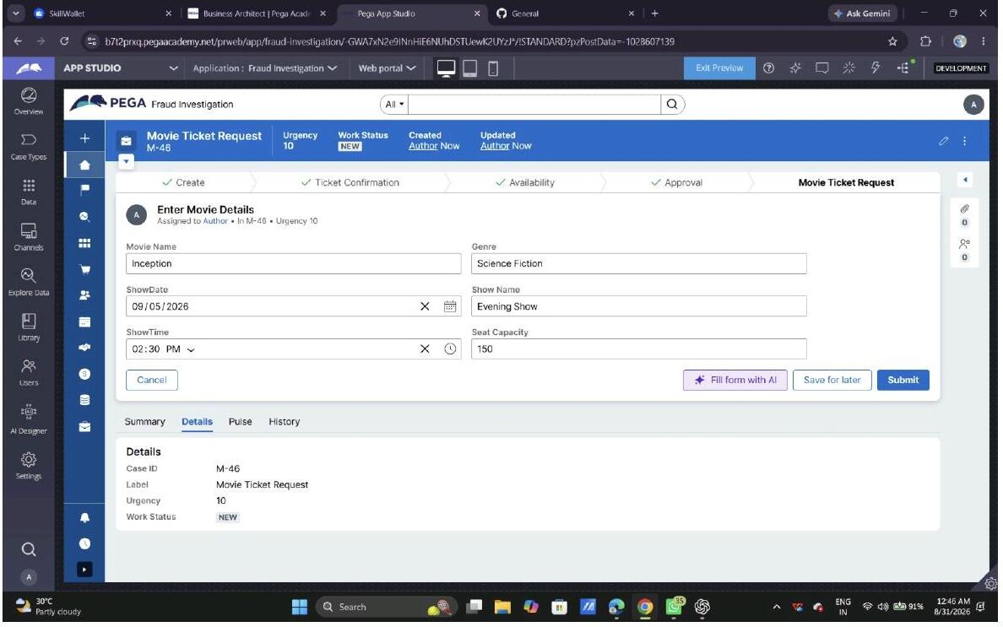
What I built for this:
Created Movie and Show data objects and an Enter Movie Details step capturing Movie Name, Genre, ShowDate, Show Name, ShowTime and Seat Capacity, linked to the case.

US-6 — Review Booking Details
What is expected:
Confirmation screen shows Movie Name, Show Timing, Number of Tickets and Total Cost clearly.
Screenshot evidence:
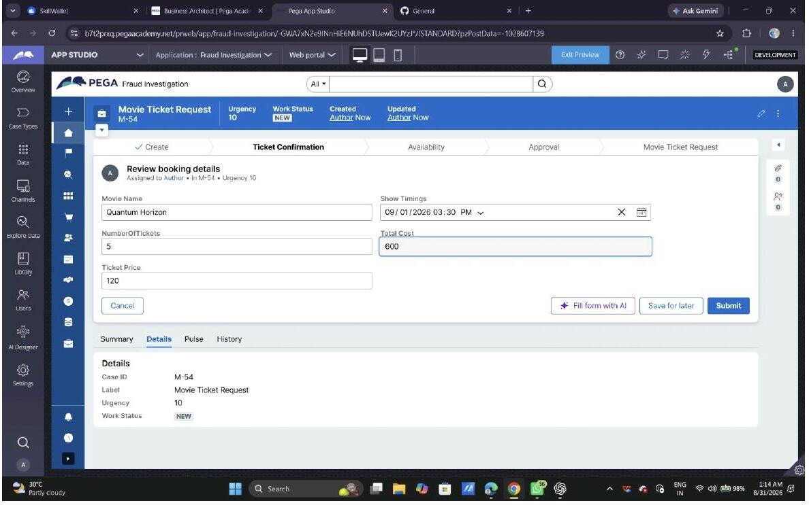
What I built for this:
Added a Review booking details step (Ticket Confirmation stage) that displays Movie Name, Show Timings, Number of Tickets, Ticket Price, and the calculated Total Cost together before the customer confirms.

US-7 — Process Ticket Booking
What is expected:
Booking Execution stage. Seat Numbers, Ticket ID and Booking Confirmation Status maintained.
Screenshot evidence:
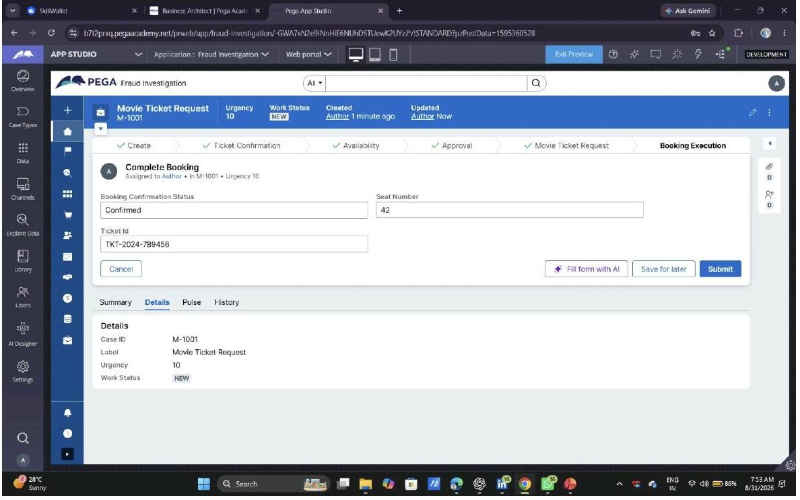
What I built for this:
Added a Complete Booking step in the Booking Execution stage capturing Booking Confirmation Status, Seat Number, and a generated Ticket Id (e.g. TKT-2024-789456).

US-8 — Notify Booking Confirmation
What is expected:
Correspondence rule triggered on case resolution. Email includes movie, show, seat and cost details.
Screenshot evidence:
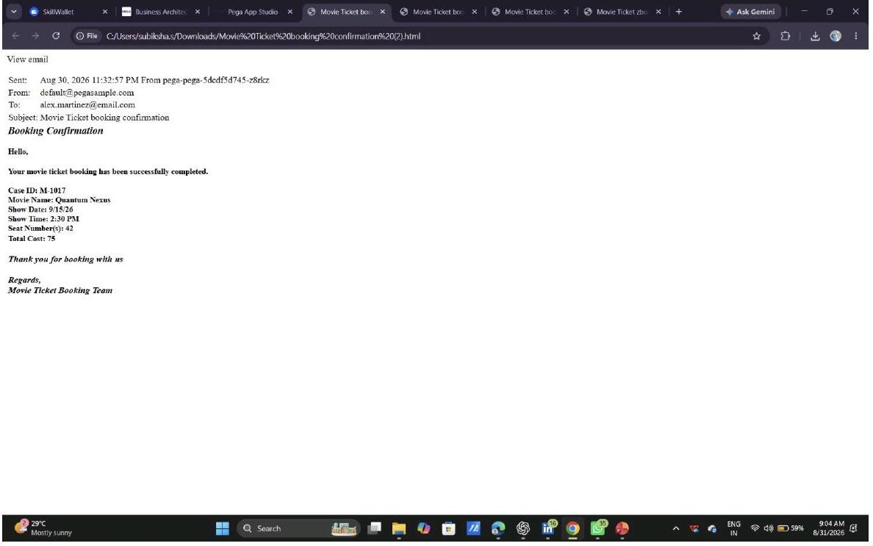
What I built for this:
Configured an email notification sent on booking confirmation, containing Case ID, Movie Name, Show Date, Show Time, Seat Number(s), and Total Cost.

US-9 — Define Booking SLA
What is expected:
SLA configured on the case type. Goal: 1 day. Deadline: 2 days. Priority increases on breach.
Screenshot evidence:
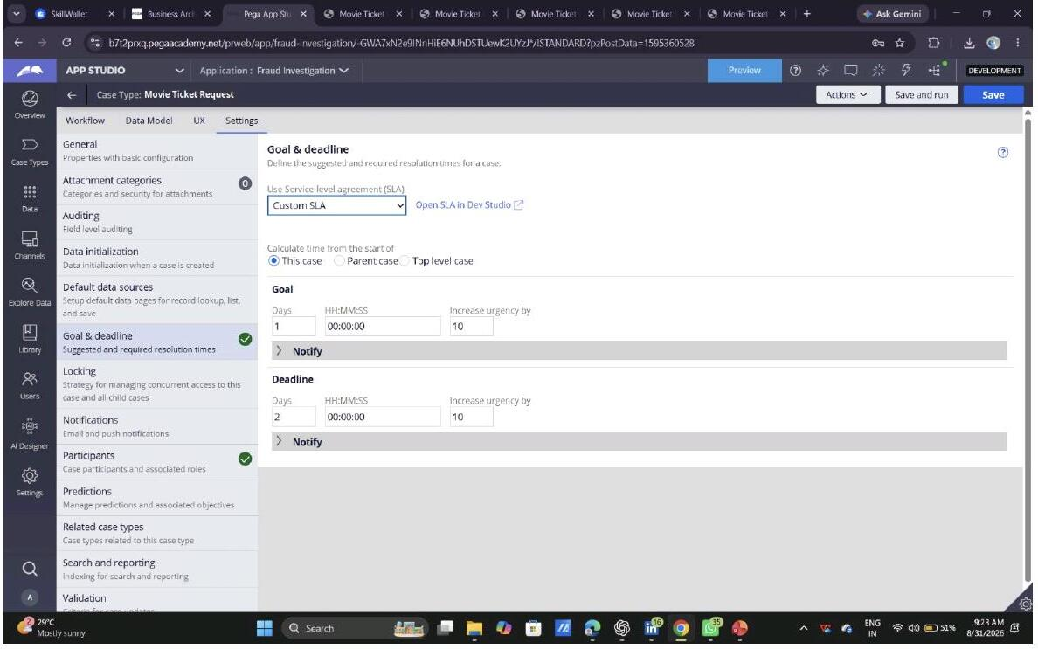
What I built for this:
Configured a Custom SLA on the Movie Ticket Request case type with a Goal of 1 day and a Deadline of 2 days, both increasing urgency by 10 on breach — matching the required SLA exactly.

US-10 — Route by Show Type
What is expected:
Routing rule or Decision Table routes to PremiumShowQueue or StandardQueue based on Show Type property.
Screenshot evidence:
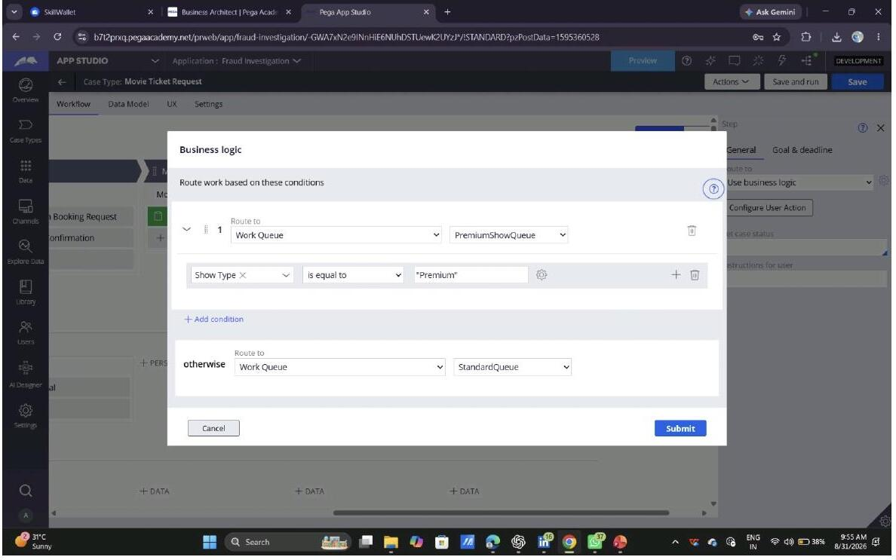
What I built for this:
Added business logic that routes on the Show Type property: Show Type = "Premium" routes to the PremiumShowQueue work queue; otherwise the case routes to the StandardQueue.

Section 3 — About Your Application
These answers are checked against your screenshots. Write exactly what is in your application.
Q1. List your stages in the order they appear in your case lifecycle.
Create, Ticket Confirmation, Availability, Approval, Movie Ticket Request, Booking Execution, Booking confirmation.
Q2. Name the data object(s) you created and the properties inside them.
Data objects: Movie and Show (visible under Data & Interfaces on the Create stage). The Enter Movie Details view (used to capture Movie/Show data) confirms these exact fields and types: Movie Name (Text – single line), Genre (Text – single line), ShowDate (Date only), Show Name (Text – single line), ShowTime (Time only), Seat Capacity (Integer).
Q3. What is the exact name and type of the rule you used to calculate Total Cost?
Property: TotalCost (Type: Integer, on the Movie Ticket Request case). Configured as a calculated, read-only field using App Studio's "Use expression" calculation option, with the expression: .TicketPrice * .NumberOfTickets. This is confirmed directly from the "Configure field" screen for Total Cost.

Section 4 — Your Understanding
Short, honest and specific answers score well.
Q4. What did Blueprint generate for you, and what did you add or change yourself afterwards?
Blueprint (using the "Ticketing and Booking" blueprint) generated a starting application with case types (Ticketing Management, Attendee Management, Event Planning, Vendor Coordination), data objects (Event, Venue, Ticket, Attendee), and personas (Ticketing Manager, Attendee). None of these generated case types was the movie-specific case type needed, so the Movie Ticket Request case type was built/configured separately — its own stages (Create, Ticket Confirmation, Availability, Approval, Movie Ticket Request, Booking Execution, Booking confirmation), fields, SLA, and routing logic were added or configured afterward.
Q5. Was there anything Blueprint created that you had to correct or configure further? Describe one example.
The Availability stage did not initially have a persona assigned to work its Check Show Availability step. A Booking Agent persona was manually added/configured so the step could be assigned.
Q6. Explain your case flow from creation to resolution, in order.
A case starts in the Create stage, where the customer enters Movie Name, Show Date, Show Time and Number of Tickets. It moves to Ticket Confirmation, where booking details (Movie Name, Show Timings, Number of Tickets, Total Cost) are reviewed. In the Availability stage, Seat Availability Status and Available Seats Count are checked (the case is blocked if seats are unavailable) and Total Cost is calculated as Number of Tickets × Ticket Price. The case then reaches Approval, where the Get Approval step is Approved or Rejected — a rejected case resolves as RESOLVED-REJECTED. If approved, the flow reaches the Movie Ticket Request stage's Enter Movie Details step to record the specific movie and show, followed by Booking Execution's Complete Booking step, where the Seat Number and Ticket Id are generated and the Booking Confirmation Status is set to Confirmed. The case resolves after a confirmation email is sent to the customer in the Booking confirmation stage.
Q7. Pick two design choices you made in your application and explain why you made them.
1) SLA design — a Custom SLA with a 1-day Goal and 2-day Deadline, both increasing urgency by 10 on breach. This was chosen so unattended bookings are automatically prioritized the longer they sit unactioned, keeping time-sensitive show bookings from stalling.
2) Queue routing by Show Type — business logic that sends Premium bookings to PremiumShowQueue and everything else to StandardQueue. This was chosen so premium show bookings can be worked separately (and with priority) instead of mixing with regular bookings, giving staff a clearer worklist.
Q8. What was the hardest part, and how exactly did you fix it?
The hardest part was seat-availability validation — making sure a booking could not be submitted once Available Seats Count reached 0. I fixed this by configuring a validation on the Check Show Availability step so that submission is blocked when the availability condition is not satisfied, and the customer sees a message telling them to pick another show or reduce the ticket count.
Q9. If the approval step was only needed when Total Cost is above a certain amount, what would you change in your application?
A decision/condition would be added before the Approval stage (or as a 'when' condition on the transition into Approval) that checks the Total Cost property. If Total Cost is below the threshold, the case would skip Approval and move directly from Availability into the Movie Ticket Request/Booking Execution stages; if Total Cost is at or above the threshold, the case would route into the existing Approval stage as it does today.
Q10. List three exact rule names from your application that you personally created or modified.
1. TotalCost — Property (calculated field, expression: .TicketPrice * .NumberOfTickets)
2. Enter Movie Details — Case step / View
3. Movie Ticket Request — Case Type
Q11. List all personas used in your application.
Customer, Booking Agent, Ticketing Manager.
Q12. List all work queues used in your application and explain when each one is used.
PremiumShowQueue — used when the Show Type property equals "Premium".
StandardQueue — fallback/default queue used for all non-Premium show types.

